Database Project: Pokemon

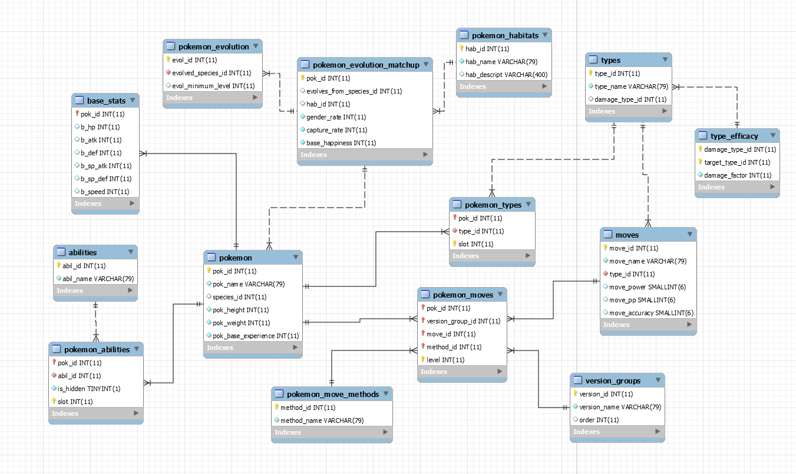

Views
- View of Pokémon with attack, defense, and hp greater than 100.
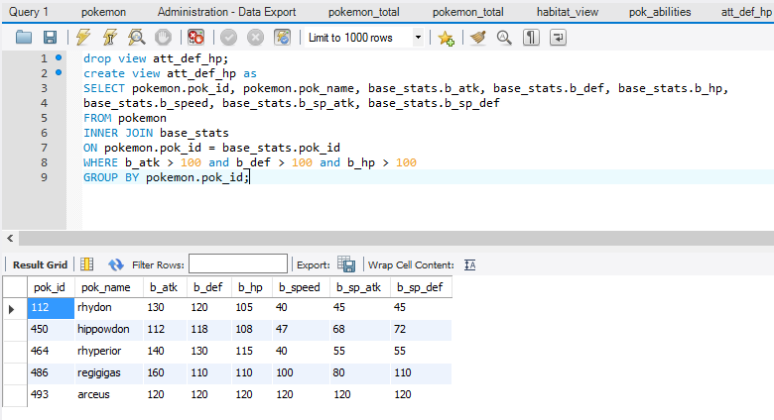

- View of Pokémon and their habitat.
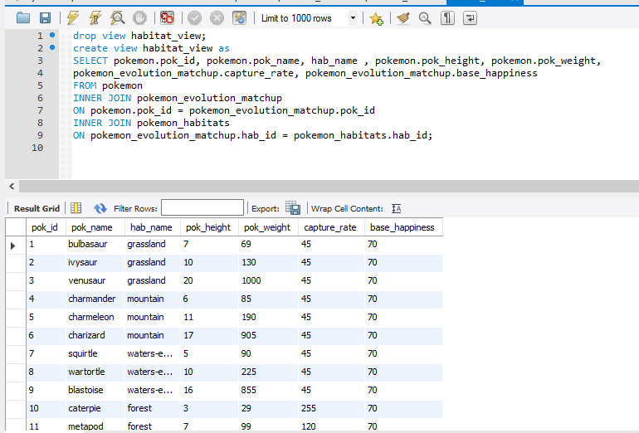

- View of Pokémon and all of their abilities.
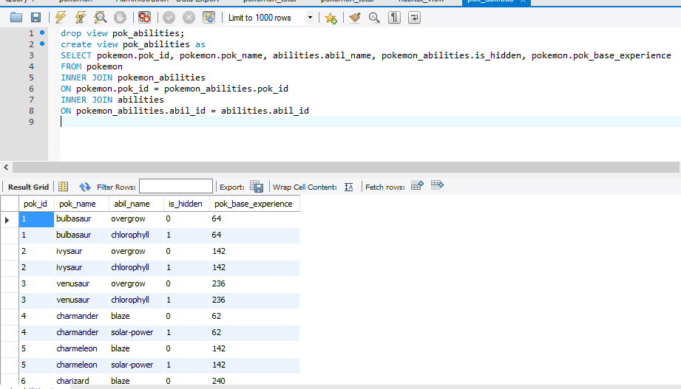

- View of the sum of all Pokémon base stats.
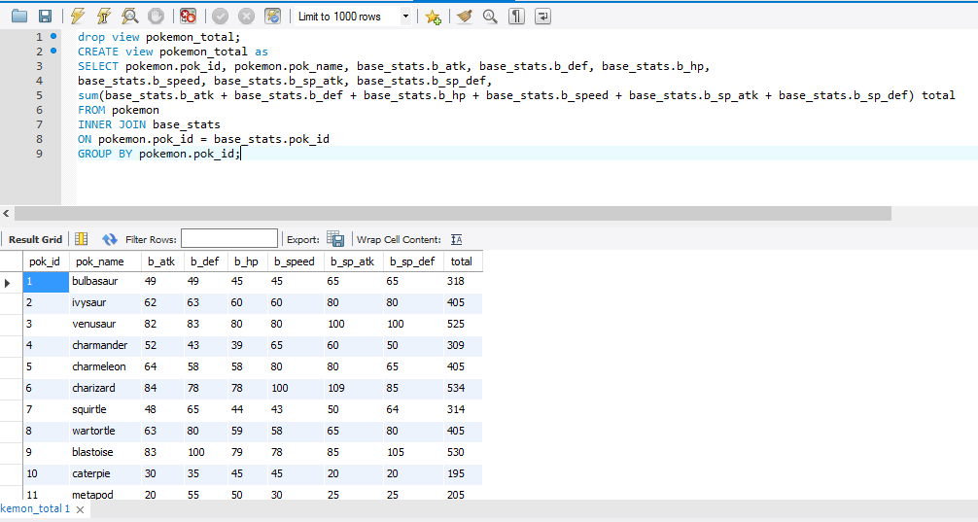

- View of the top 10 Pokémon total base stats.
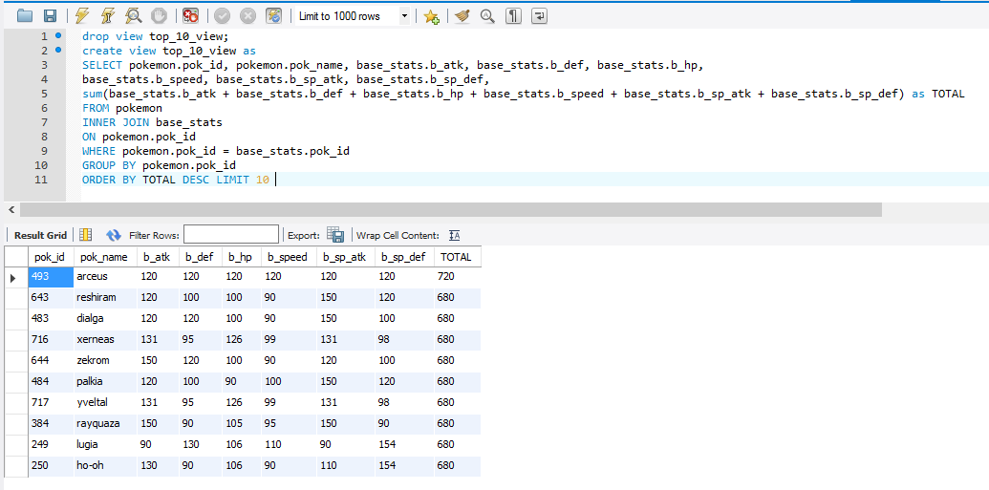

Stored Procedures
- Input a Pokémon’s name and returns their abilities.
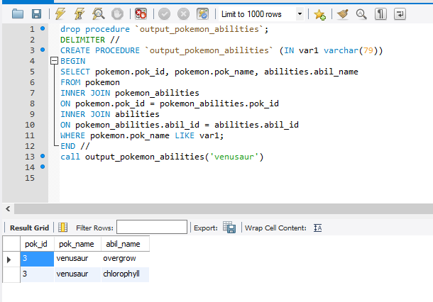

- Input a Pokémon’s name and returns all their base stats.
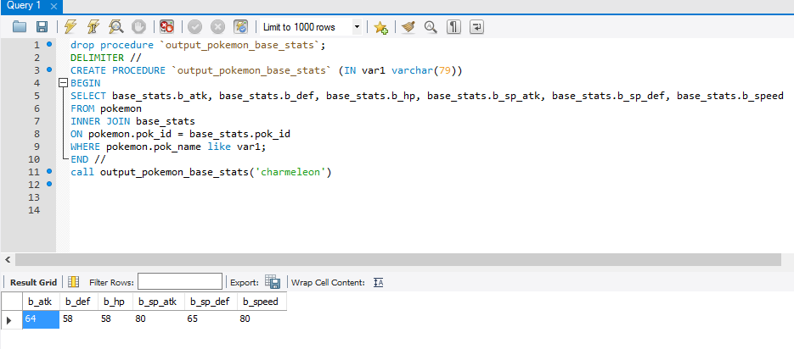

- Input a Pokémon’s id and returns their name and evolution.
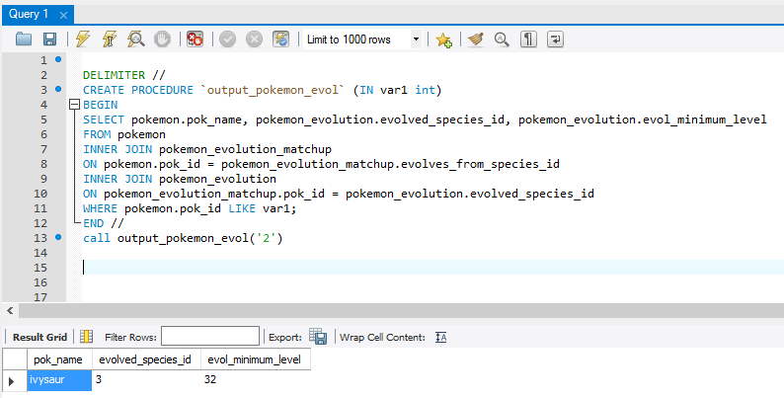

- Input a move and Pokémon name. If there is a return then the Pokémon has fainted. If there is no return then the Pokémon did not faint.
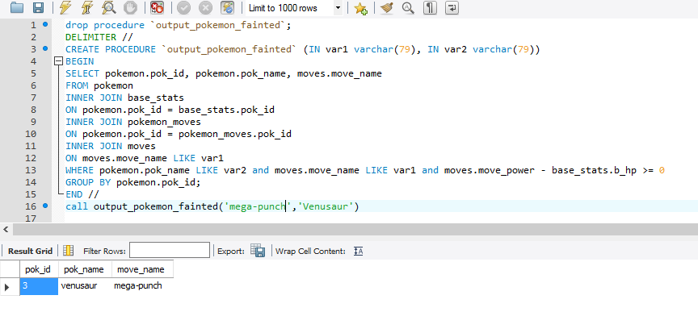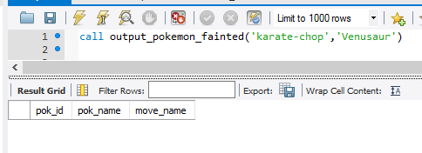

- Input a habitat and returns all the Pokémon in that habitat.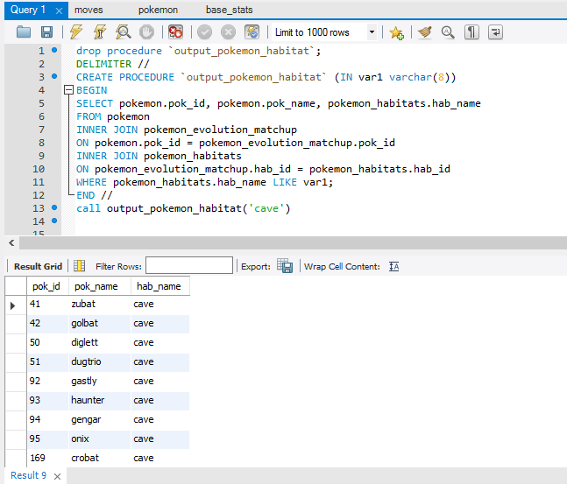
- Input a Pokémon name and return their hidden ability.
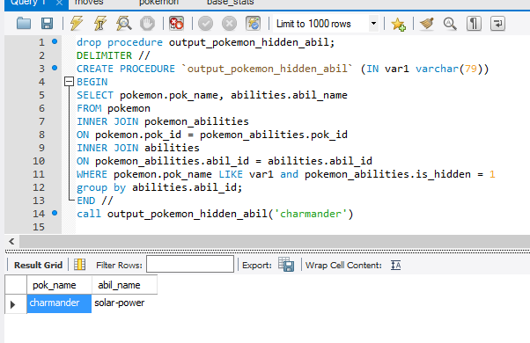

- Input a Pokémon’s name and return all their moves.
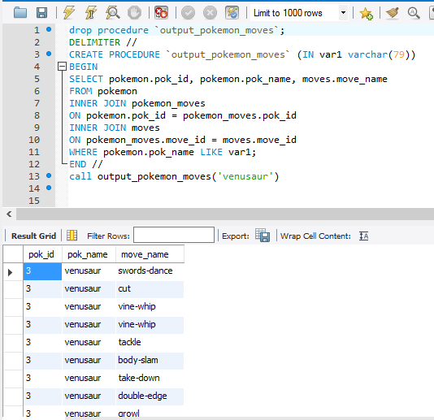

- Input a Pokémon move and returns how a Pokémon can learn that move.
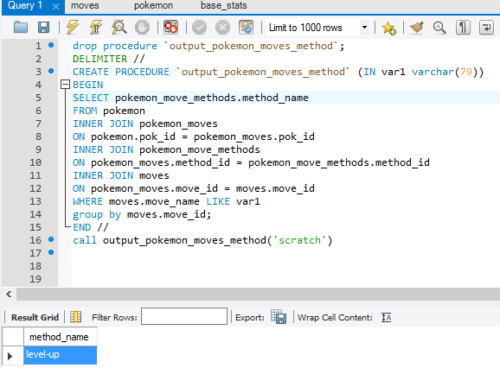

- Input a Pokémon move and return the type that move is.
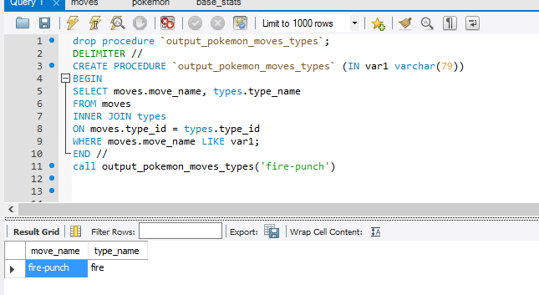

- Input a move and return the game version of the move.
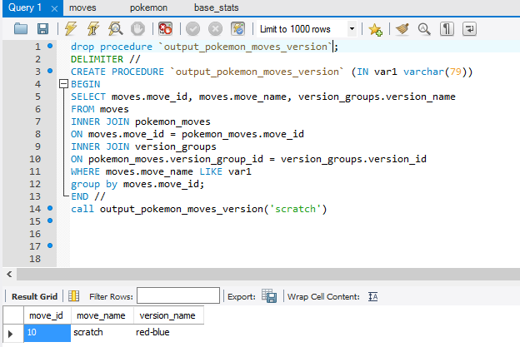

- Input a type and return the damage factor.
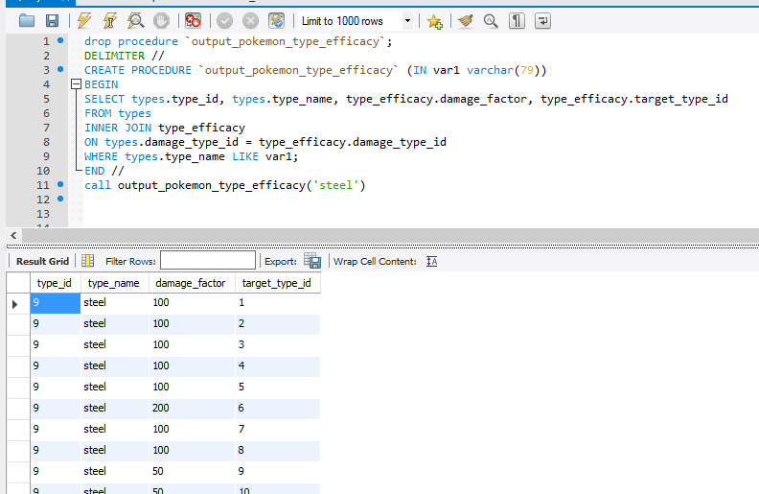

- Input a Pokémon’s name and return their type.
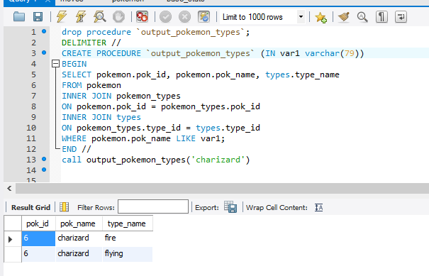

Triggers

- If insert for height, weight, or base experience is negative than it will be set to 0.
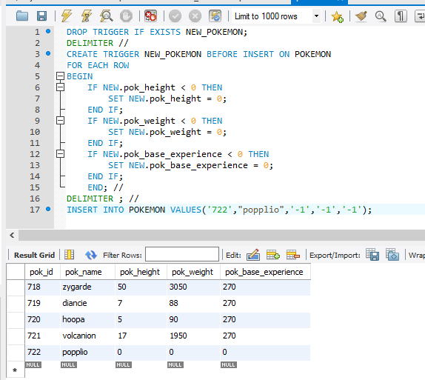
- If the insert for habitat name and description is empty then it is set to Unknown.
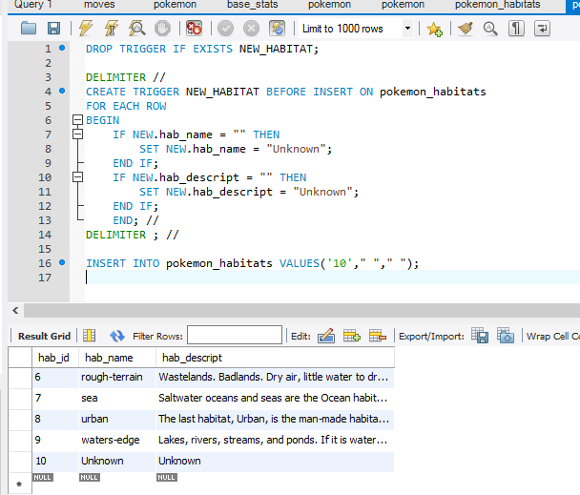

- The insert for hidden ability needs to be 0 or 1, or will be set to 0.
The insert for slot needs to be 1,2, or 3 or else it will be set to 1.
